The Tecsun PL-310 AM-FM-SW-LW DSP Receiver
Four Band Performance Review
By Gary DeBock, Puyallup, WA USA October 2009

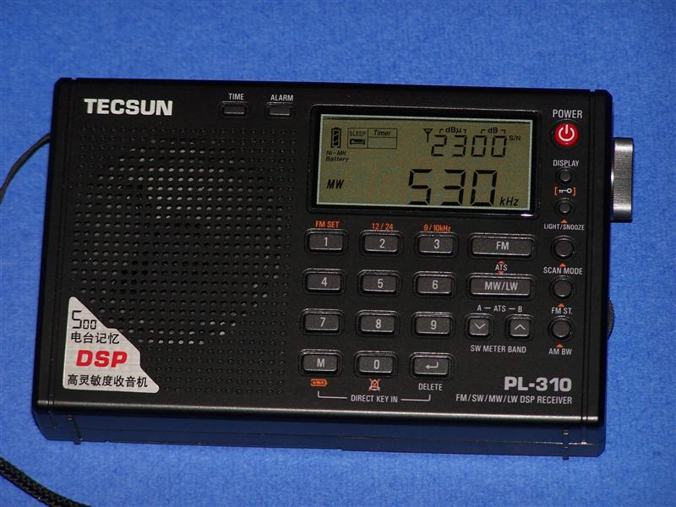

Introduction The Tecsun PL-310 is the latest DSP-enhanced pocket radio produced by China’s premier electronics manufacturer, and was designed to fully utilize all the innovative functions available from the American-designed Silicon Labs’ 4734 DSP chip. A product of the intense competition in the Chinese domestic market, the radio was designed to compete favorably with the Kchibo D96L model, which was introduced in August with very similar features. Because of the economics of the Chinese domestic market, the Tecsun and Kchibo companies have invested heavily in the practical application of the 4734 DSP chip in inexpensive consumer radios, producing models with astonishing capabilities—and very low prices.
The PL-310 was eagerly anticipated by hobbyists desiring a high quality pocket radio with the full range of DSP selectivity choices available from the 4734 DSP chip—1, 2, 3, 4 and 6 kHz filtering options. Such choices were initially offered in the Kchibo D96L model, but with various quirks that made some DXers less than satisfied. In this mini-review, the PL-310 will be extensively compared with the D96L, as well as with the Tecsun PL-300WT (a.k.a. G8), Tecsun’s initial DSP pocket radio model. Such a detailed comparison should enable prospective purchasers to make a decision whether the new PL-310 model will meet their needs.
The PL-310 Design Strategy The PL-310 is essentially a refinement of Tecsun’s PL-300WT model, introduced in May as the first Chinese-market pocket radio featuring the Silicon Labs’ 4734 DSP chip. Although the PL-300WT (and its Grundig G8 clone) provided unprecedented AM selectivity and unmatched FM-DXing performance, there was no choice of DSP selectivity options on AM, and the single fixed option was not at the optimum 1 kHz setting. The radio also suffered from common inductance mismatches between the loopstick and the DSP chip, resulting in less-than-optimum AM and LW sensitivity.
China’s Kchibo company took advantage of these shortcomings by introducing their D92L and D96L pocket radio models in July and August respectively, both of which offered the full range of DSP selectivity options from the 4734 chip. Whereas the D92L model was hampered by severe design quirks, the D96L model has proven to be a very formidable AM-DXing receiver-- with most of the D92L quirks corrected. Both of these models (as well as the PL-300WT) are fully covered in the 2009 Ultralight Radio AM-DX Shootout article, in which the Kchibo D96L was judged to be the winner in both AM sensitivity and selectivity. The new PL-310 represents the Tecsun company’s best efforts to produce a DSP pocket radio superior to the D96L, and to restore its premier position in this new Chinese domestic market radio category.

The PL-310 Basics Physically, the PL-310 is very similar to the PL-300WT (G8) models, and may be pictured as a PL-300WT with a round tuning knob on the right side. At 5.5” x 3.3” x 1.1” (140 x 87 x 27 mm), the radio barely fits within the 20 cubic inch Ultralight definition limit when the volume of the protruding tuning knob is taken into account. As a 4734 DSP chip-based radio, the display features selectable options of signal strength /signal-to-noise ratio, temperature (selectable in Celsius or Farenheit), current time, and alarm time setting. As a major improvement over its PL-300WT predecessor, the PL-310 has selectable 1, 2, 3, 4 and 6 kHz DSP selectivity options available from a front panel control (in a carousel rotation scheme). Another major improvement over the PL-300WT is an excellent direct-entry keypad with generous-sized numeral controls (which operates without the typical need to push an “enter” button). There are 500 preset memories available, and an alarm function which can awaken the owner with either a buzzer, or a live radio signal.
Unlike the PL-300WT with its mismatched loopstick, the PL-310 has competitive LW coverage, which runs from 153-513 kHz. AM coverage is from 520-1710 kHz when 10 kHz steps are selected, and from 522-1620 kHz when 9 kHz steps are selected. The AM tuning rate is adjusted according to the user’s rotation of the tuning control, so that rapid rotation of the tuning control shifts the tuning rate from 1 kHz to either 9 or 10 kHz steps (whichever steps are selected by the user for his local area). When the tuning knob rotation is slowed down, the AM tuning rate shifts back to 1 kHz. Even if 10 kHz tuning steps are selected, a transoceanic DX-chaser can still manually tune in the 9 kHz-split frequencies with the tuning control.
Highly sensitive and selective FM coverage is from 64-108 MHz, and FM stereo audio is available from the earphone jack when such stations are received. The FM tuning rate also is adjusted according to the owner’s rotation of the tuning knob, with the slower 10 kHz steps changing to 100 kHz steps when the tuning knob rotation is faster.
SW coverage on the PL-310 is from 2.3 MHz to 21.95 MHz, selectable in 13 different band segments from the front panel. In a major improvement over the PL-300WT’s reception of numerous AM spurs and mixing products throughout the SW spectrum, the PL-310 SW coverage is free of these problems.
Four different tuning methods are available: manual (tuning knob) rotation, direct frequency entry (using the keypad), “Auto Tuning Storage” (scanning of available stations into memory), and memory recall tuning.

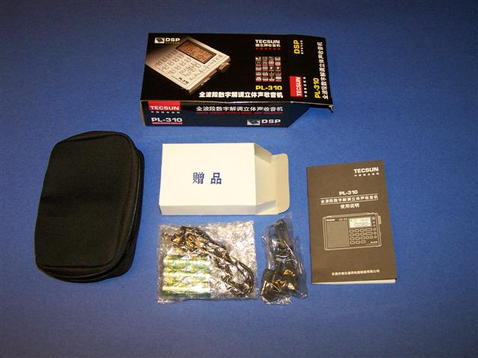
The Tecsun PL-310 is powered by three 1.5v AA batteries (or a 4.5v adapter), and is available in black, silver or gray colors. It comes with three rechargeable AA batteries, a USB cable (to charge the batteries from your computer), stereo earphones, a vinyl carrying case, a wrist strap, and a Chinese owner’s manual (an English manual has been promised to current purchasers, to be provided “very shortly”). The PL-310 is currently available for $39.99 plus $24.00 shipping (by registered airmail to North America) from the top-rated eBay seller “Anon-co,” who will probably be joined by other Chinese eBay sellers once the PL-310 orders increase.

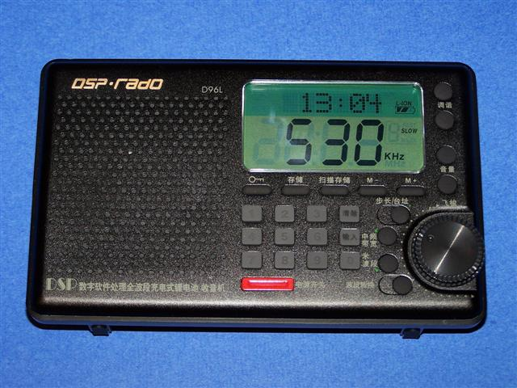
Competitive Performance To fully investigate its DXing capabilities, the new PL-310 model was tested against competing top-rated Ultralight radio models on all four bands. For LW testing, it was matched against its PL-300WT predecessor (the only other Ultralight radio with LW coverage). For AM band testing, it was matched against the new Kchibo D96L model (the
sensitivity and selectivity winner in the recent 2009 Ultralight Radio AM-DX Shootout, pictured at left), and the PL-300WT. On the FM band, the PL-310 was up against the top-rated PL-300WT, as well as the D96L. Finally, on the SW bands it was matched against the PL-300WT and the Eton E100 (a.k.a. Tecsun PL-200), which is generally considered the top-performing Ultralight radio in SW performance. All models were provided with new batteries (or recharged batteries) and operational checks prior to the live signal competition.

LW Testing The PL-310 was tested against the PL-300WT in the reception of NDB beacons just past local midnight (0800 UTC) on October 10, 2009. The new PL-310 was able to receive the following four beacons, on the approximate frequencies listed:
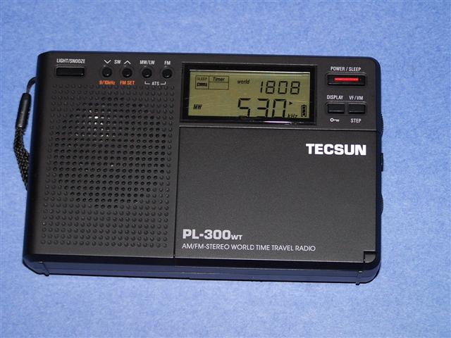
“NY” (351 kHz)…. Strong
“ZP” (369 kHz)…. Moderate
“QQ” (398 kHz)…. Moderate
“MOG” (405 kHz)…. Weak

Of these four beacons, the PL-300WT model was able to receive only a trace of the “NY” beacon (at very weak strength). The PL-310’s LW performance was judged to be far superior to that of the PL-300WT, and as such is the Ultralight radio class performance leader in LW-DXing capability.

AM Testing Both sensitivity and selectivity comparisons were made against the top-rated Kchibo D96L model, and the PL-300WT model. Tests were made at 1400 local time on October 10, 2009, in Puyallup, WA (35 miles south of Seattle). The PL-300WT model had been aligned on AM for best sensitivity, but the D96L and PL-310 models were tested as received from the Chinese eBay sellers. Selectivity was tested in the 1 kHz DSP option on both the D96L and PL-310 models.

AM SENSITIVITY (best is 5; worst is 0)

620-KPOJ 750-KXL 1130-CKWX 1280-KIT 1380-KRKO 1640-KDZR

PL-310 (A) 2.5 3 4 3.5 3.5 3
D96L (A) 3 3 3.5 3 3 3.5
PL-300WT (B) 1 2 3 2 2 2

Sensitivity Summary: The PL-310 has sensitivity roughly equivalent to that of the D96L, but the new PL-310 has an advantage over the middle frequencies, while the Kchibo D96L has a slight advantage on the extreme upper and lower band frequencies. The PL-300WT is outclassed by these two top models.

AM SELECTIVITY (best is 5; worst is 0)

560-KPQ 1080-KFFX 1370-KAST 1460-KARR

PL-310 (A) no KVI slop (5) slight KPTK slop (4) moderate KKMO slop (3) no KSUH slop (5)
D96L (A) no KVI slop (5) slight KPTK slop (4) moderate KKMO slop (3) no KSUH slop (5)
PL-300WT slight KVI slop (4) heavy KPTK slop (2) almost all KKMO slop (1) heavy KSUH slop (2)
(B)

Selectivity Summary: The PL-310’s selectivity is exactly equal to that of the D96L, with both models showing impressive performance on all test signals. The PL-300WT was again outclassed, due to the lack of a 1 kHz DSP selectivity option.

AM QUIRKS: The PL-310 suffers from the same internally-generated AM heterodynes as the PL-300WT (G8) models, notably around 640, 980, 1400-1430 and 1600-1640 kHz. As with all the 4734 DSP chip radio models (PL-300WT, D92L and D96L), the “soft mute” function causes a serious drop-off in signal strength when tuning 1 kHz up or down from a DX station’s frequency, during attempts to escape local QRM. This function also causes “audio pumping” of the AGC action, making it less than effective in smoothing out variations in stations’ signal strength. Unlike the PL-300WT, there is apparently no way to disable the dual tuning rate controlled by the speed of tuning knob rotation. There is currently no English owner’s manual for the PL-310, although one has been promised by the eBay seller “Anon-co” for recent purchasers.

FM Testing The PL-310 was tested in the reception of various FM fringe stations against the top-rated PL-300WT, and also the D96L. Tests were made during average daytime conditions in Puyallup, WA (35 miles south of Seattle). The built-in whip antennas were used, with fully extended lengths.
Since all these units use the same 4734 DSP chip on FM, FM selectivity was identical for all three models. However, the variations in FM sensitivity are detailed in the following information.

FM SENSITIVITY: (best is 5; worst is 0)

KISM-92.9 CIOC-98.5 CKKQ-100.3 CFMI-101.1 KINK-101.9 KKCW-103.3

PL-310 (A) 3 5 3 2 2 2
D96L (B) 2 4 1 0 0 0
PL-300WT (A) 3 5 3 2 2 2

FM Sensitivity Summary: The new PL-310 and its PL-300WT predecessor have identical FM sensitivity, which is superb in the reception of very distant fringe stations (most of the above stations are over 100 miles distant). The D96L apparently has a less effective whip antenna design, making its FM sensitivity a shade less impressive.

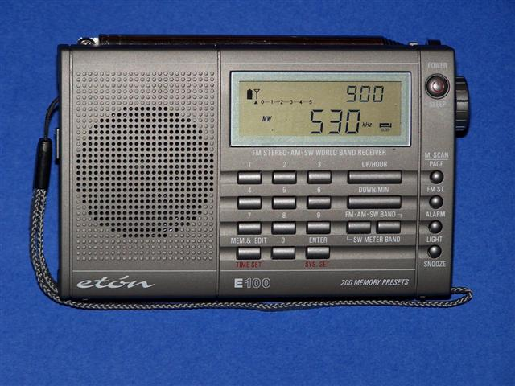
SW Testing The PL-310 was tested against the PL-300WT, and also the top-rated SW Ultralight radio, the Eton E100 (a.k.a. Tecsun PL-200), shown at left. Checks were made in the reception of several broadcast stations on the 19m (15 MHz) international band. Checks were also made on the lower SW bands for spurious AM-band signals, and mixing products (a serious problem in the PL-300WT).

SW SENSITIVITY: (best is 5; worst is 0)

WWV-15.000 UnID Spanish 15.110 WYFR-15.440 World Harvest 15.665

PL-310 (A-) 4 4 5 5
E100 (A) 5 5 5 5
PL-300WT (A-)* 4 4 5 5

* the PL-300WT has a severe problem, in which all these SW stations are mixing with the local KHHO-850 station, an IBOC pest 5 miles distant. Touching the whip antenna makes these nuisance signals disappear.

SW Sensitivity Summary: The new PL-310 has a shade less SW sensitivity than the Eton E100 (PL-200) model, and has equal SW sensitivity with the PL-300WT. The PL-300WT’s severe problem with AM spurs and mixing problems throughout the SW spectrum been corrected in the PL-310, and the radio is an effective, stable SW receiver.

Tecsun PL-310 Verdict The latest DSP pocket radio from Tecsun is astonishing in its value and versatility, with unsurpassed sensitivity and selectivity on three different bands (AM, FM and LW). Tecsun has combined the outstanding FM performance of the PL-300WT with highly effective DSP filtering options on AM, and has improved the loopstick as well. With the LW design improvements added to the package, Tecsun has created what is very close to being a multiband dream radio—and an unbeatable bargain at $39.99 plus shipping.
In competition with the Kchibo D96L (the winner of the recent 2009 ULR AM-DX Shootout in both sensitivity and selectivity), the PL-310’s overall AM performance is roughly equivalent, and highly impressive. But these radios have different quirks, which may influence a purchaser’s decision. The PL-310 has a more serious issue with internally-generated heterodynes, which have disappointed various PL-300WT (G8) owners. But the D96L has its own problem with digital “chuffing noise” for 5 seconds whenever a control is changed, temporarily degrading AM sensitivity during DXing (and during MP3 recordings). The construction and style of the two competing radios is also quite different, with the PL-310 having a more traditional rectangular cabinet, and the D96L having a rounded-edge tapered style.
When the additional bands are considered, however, the PL-310 is the runaway winner in value over the D96L. It has superior FM and SW performance, and whereas the D96L has no LW coverage, the PL-310 has excellent LW capability. The superb multiband performance of the new Tecsun model certainly sets a high new standard for Ultralight radios, and is certain to attract many more hobbyists to the unique thrills and excitement of pocket radio DXing.

73 and Best Wishes,

Gary DeBock

